**Big Mountain Ski Resort Summary**

Goal of project is to determine Big Mountains ticket price based off of market, identify important features contributing to ticket price, and test various scenarios for changes in features and how that would affect ticket price and revenue.

**Adult weekend ticket prices**

|  |  |
| --- | --- |
| **Big Mountain current price** | $81 |
| **National average** | $63 |
| **Modeled Big Mountain value** | $95.87 |

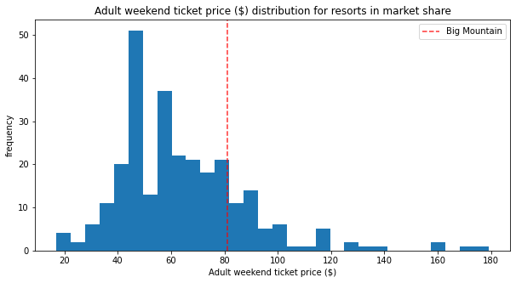

* Adult weekend ticket prices due to least number of missing values when compared with weekday ticket prices.

**Ranked importance between features in contributing to adult weekend ticket prices**

|  |  |  |
| --- | --- | --- |
| **Feature** | **LM importance** | **RF importance** |
| **Vertical drop** | **1** | **4** |
| **Snow making acres** | **2** | **3** |
| **Total chairs** | **3** | **6** |
| **Fastquads** | **4** | **1** |
| **Runs** | **5** | **2** |
| **Longest run** | **6** | **15** |

* Vertical drop, snow making acres, total chairs, fastquads, and runs were found to have the strongest influence on adult weekend ticket prices according to the two models prices for weekend
* Longest run is shown here simply to demonstrate major drop in importance on ticket prices relative to higher ranking features as demonstrated for RF model. LM also numerically demonstrated a major drop in importance.
* Longest run, trams, and skiable terrain also influence price but are of lesser importance than those mentioned in the first bullet point above.

**Big Mountains market position for important features**

|  |  |
| --- | --- |
|  |  |
|  |  |
|  |  |
|  | |

* Big Mountain places within the upper tier for features with strongest influence on ticket price.

**Influence of closing runs on ticket price**

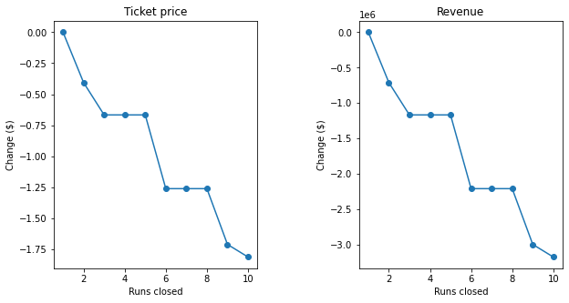

* Due to high number of runs at big mountain, closure of runs would result in a minimal drop in revenue and ticket prices.
* In order to minimize impact on revenue, closure of up to five runs should be carried out first. If this is successful, a closure of three more runs could be carried out.

**Vertical drop +150 feet, +1 run, +1 chair lift**

* This scenario increases support for ticket price by $8.61
* Over the season, this could be expected to amount to $15065471

**Vertical drop +150 feet, +1 run, +1 chair lift, +2 acres of snow**

* This scenario increases support for ticket price by $9.90
* Over the season, this could be expected to amount to $17322717

**Longest run +0.2 mile, +4 acres of snow**

* This scenario leads to a $0 increase in revenue

**Model for determining ticket price is available to test various feature scenarios**